**Playwright**

* Works in Headless mode
* No need of writing waits explicity
* Supports functional testing
* End to End testing tool
* Cross platform & Cross browser
* Locators are the central piece of Playwright's auto-waiting and retry-ability

**NuGet Packages**

* Microsoft.Playwright -> for Console Application
* Microsoft.Playwright.NUnit -> for NUnit

npm install playwright --strict-ssl=false

npm init playwright@latest

**Apache JMeter (Load testing & Volume testing tool)**

* Pure Java open source software

Click on apache-jmeter folder **->** click on bin **->** double click on jmeter(Windows Batch File) to open jmeter

**SUL** -> System Under Load

**AUT** -> Application Under Test

**Terminology**

* Master-> controls the test
* Slave
* Target-> system or application

**Summary Report** -> we will get Throughput

**Ramp up time** -> total time taken to complete the task

**Thread group ->**

**Record Test Plan**

**Add Proxy in chrome (like port number 8888)**

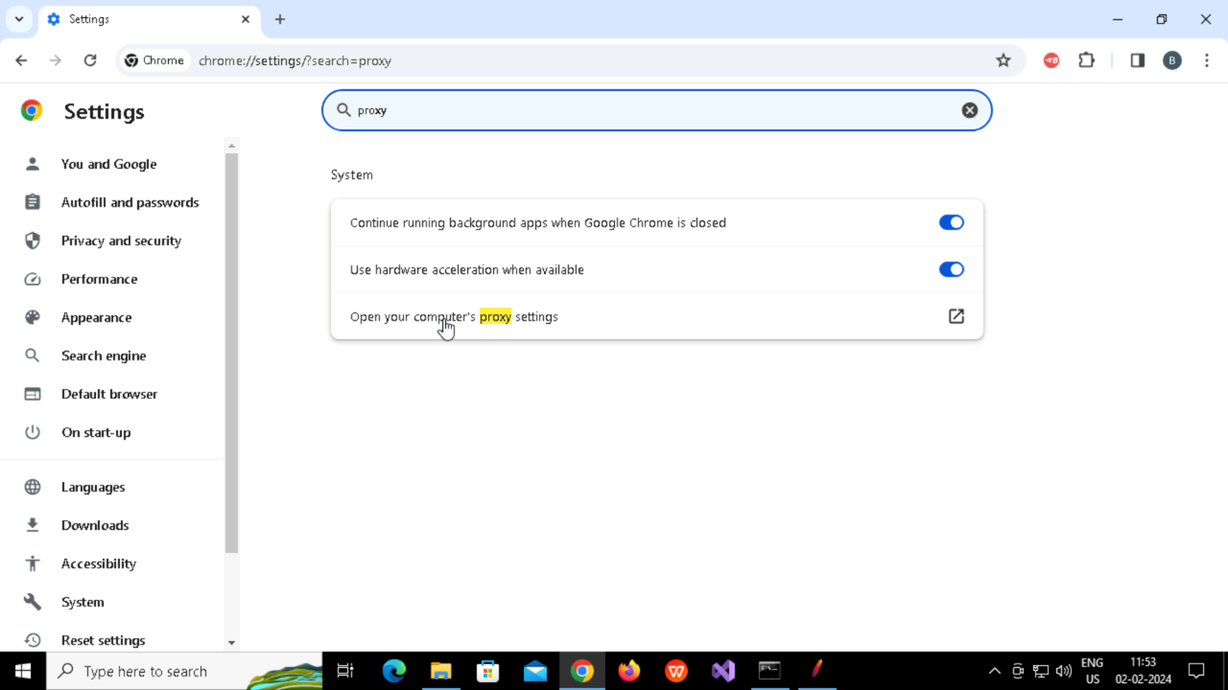

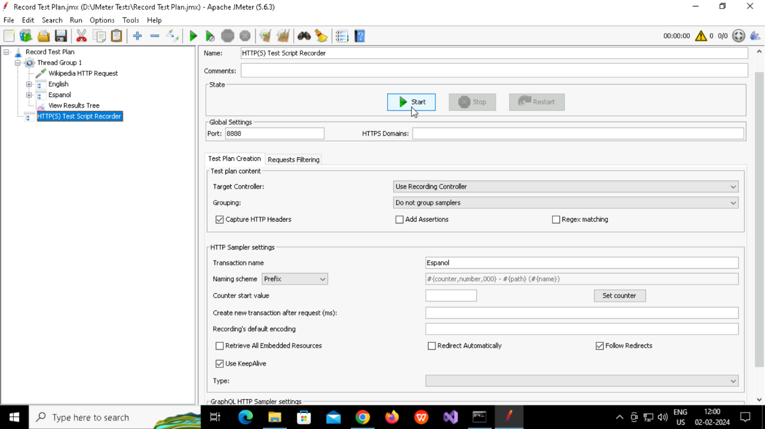

**Before running check once , It will be automatically downloaded, This certificate will expire in 7days**

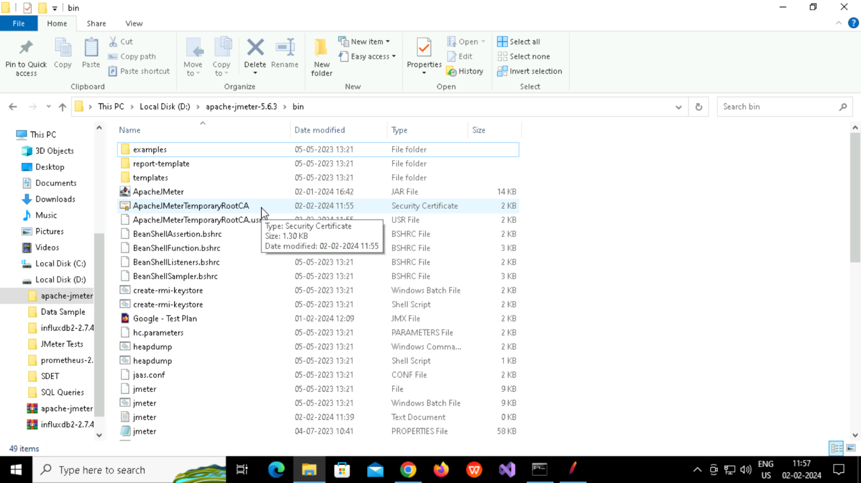

**Manage SSL Certificate**

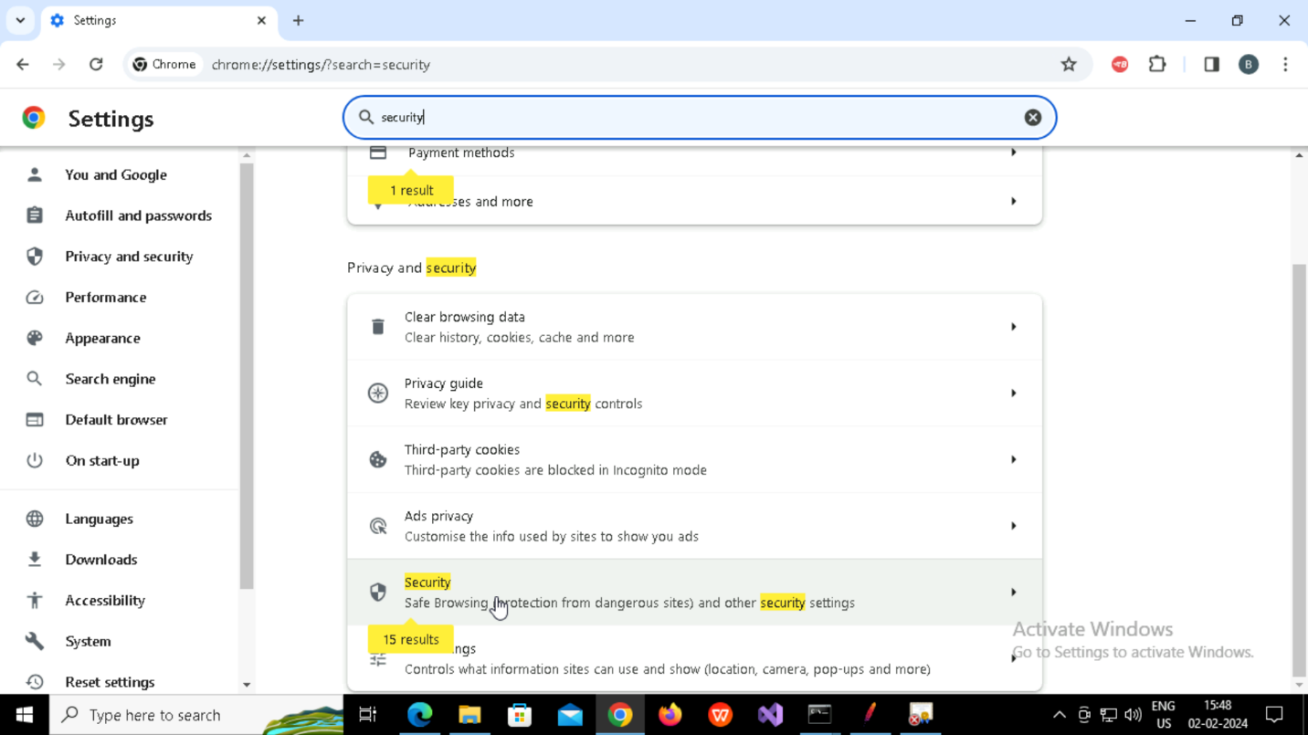

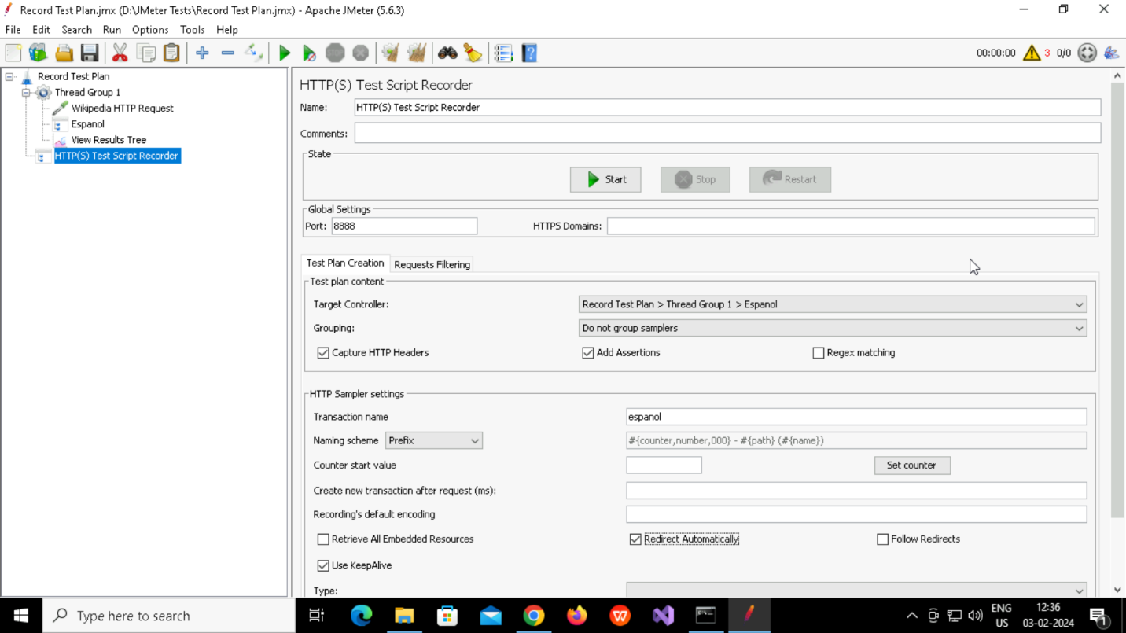

**Select particular Target Controller & Click On Start button**

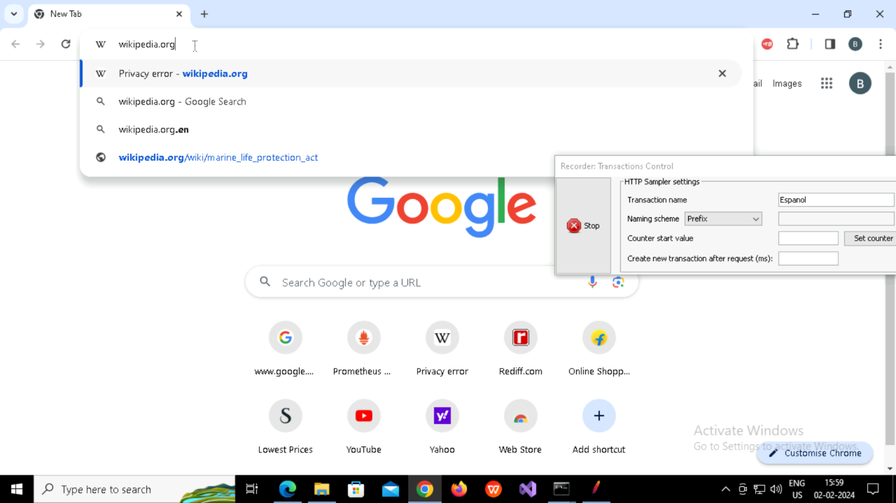

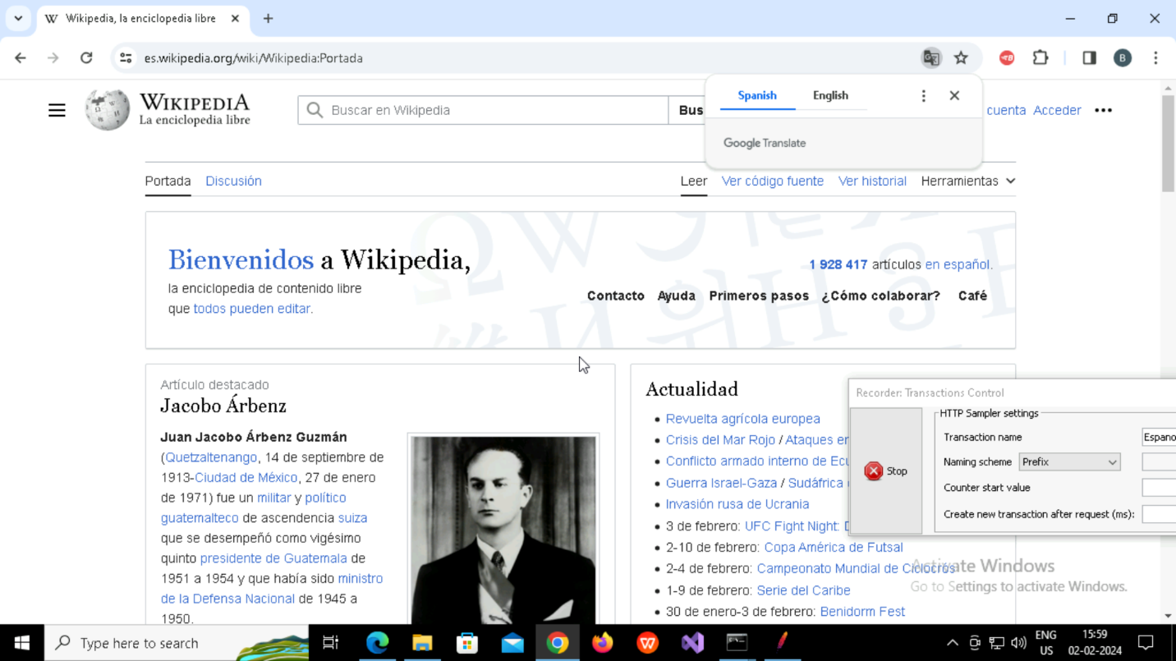

**It will be recorded in Espanol like this (Recording Controller)**

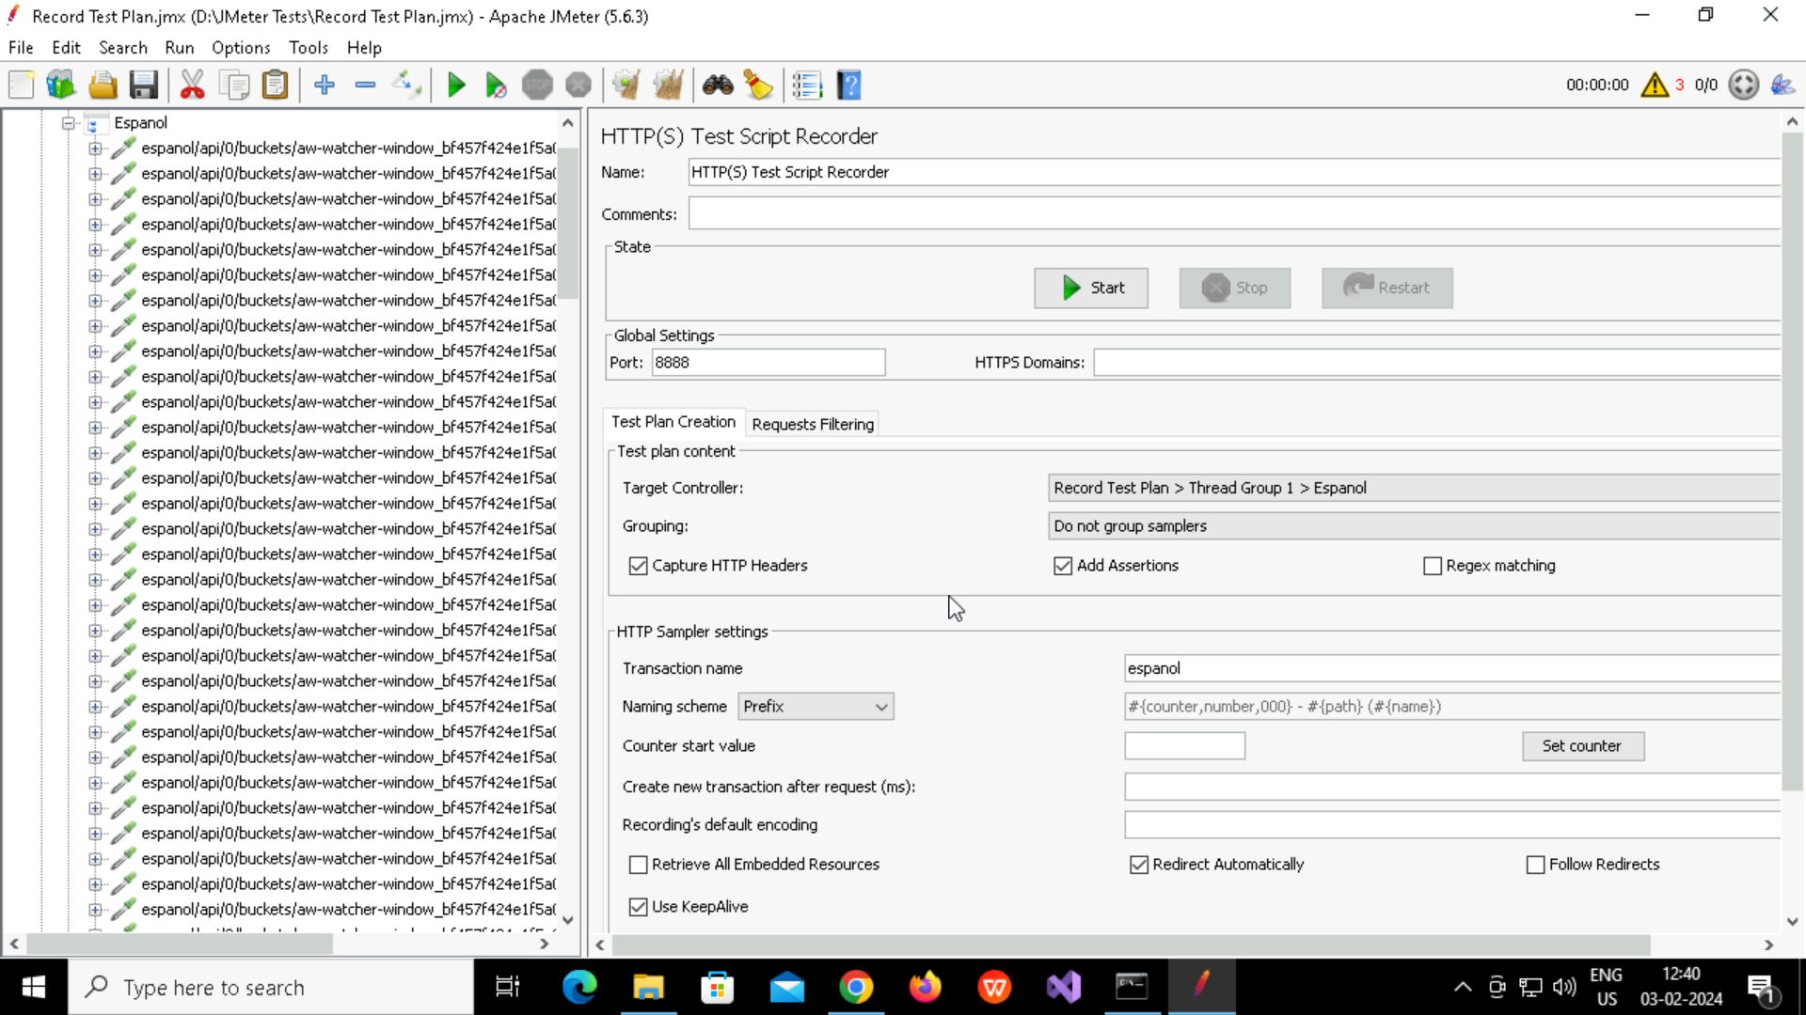

**See the particular server is hitting or not (www.wikipedia.org)**

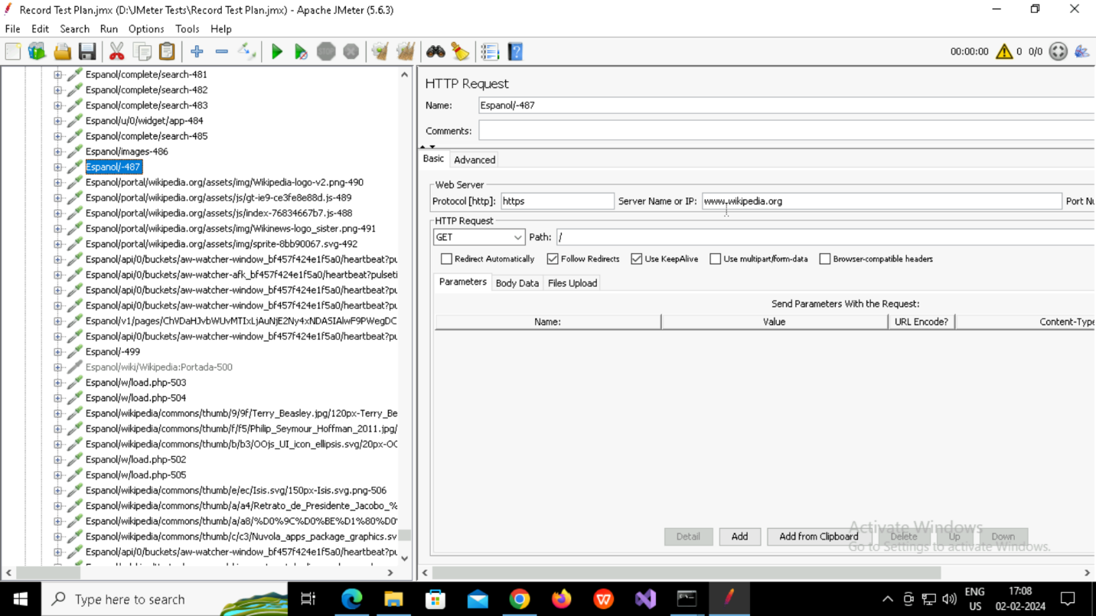

**See from** [**www.wikipedia.org**](http://www.wikipedia.org) **it’s redirecting to Espanol**

**Filtering the requests**

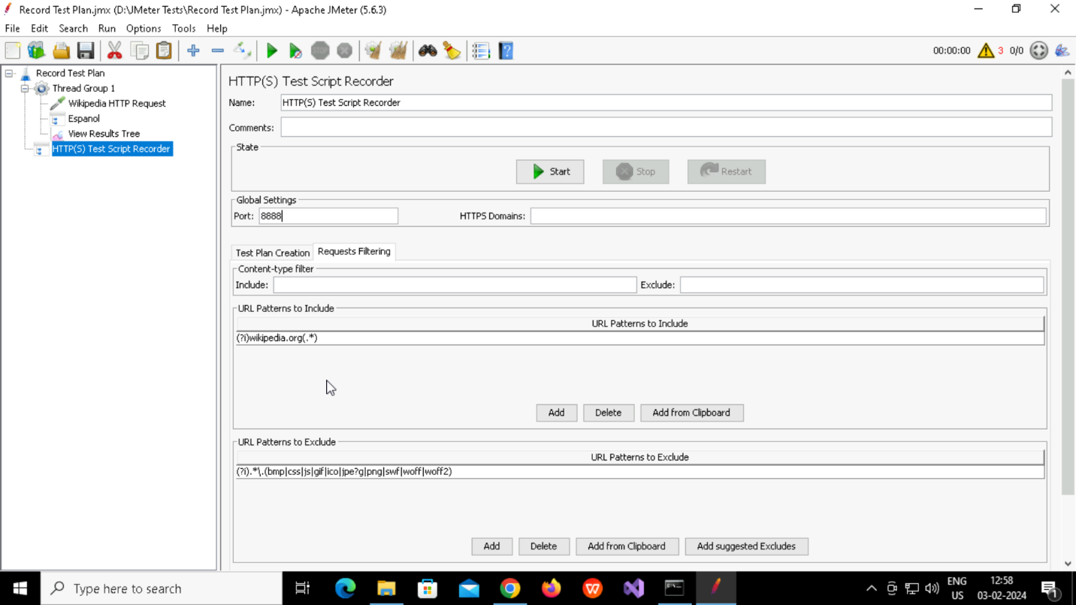

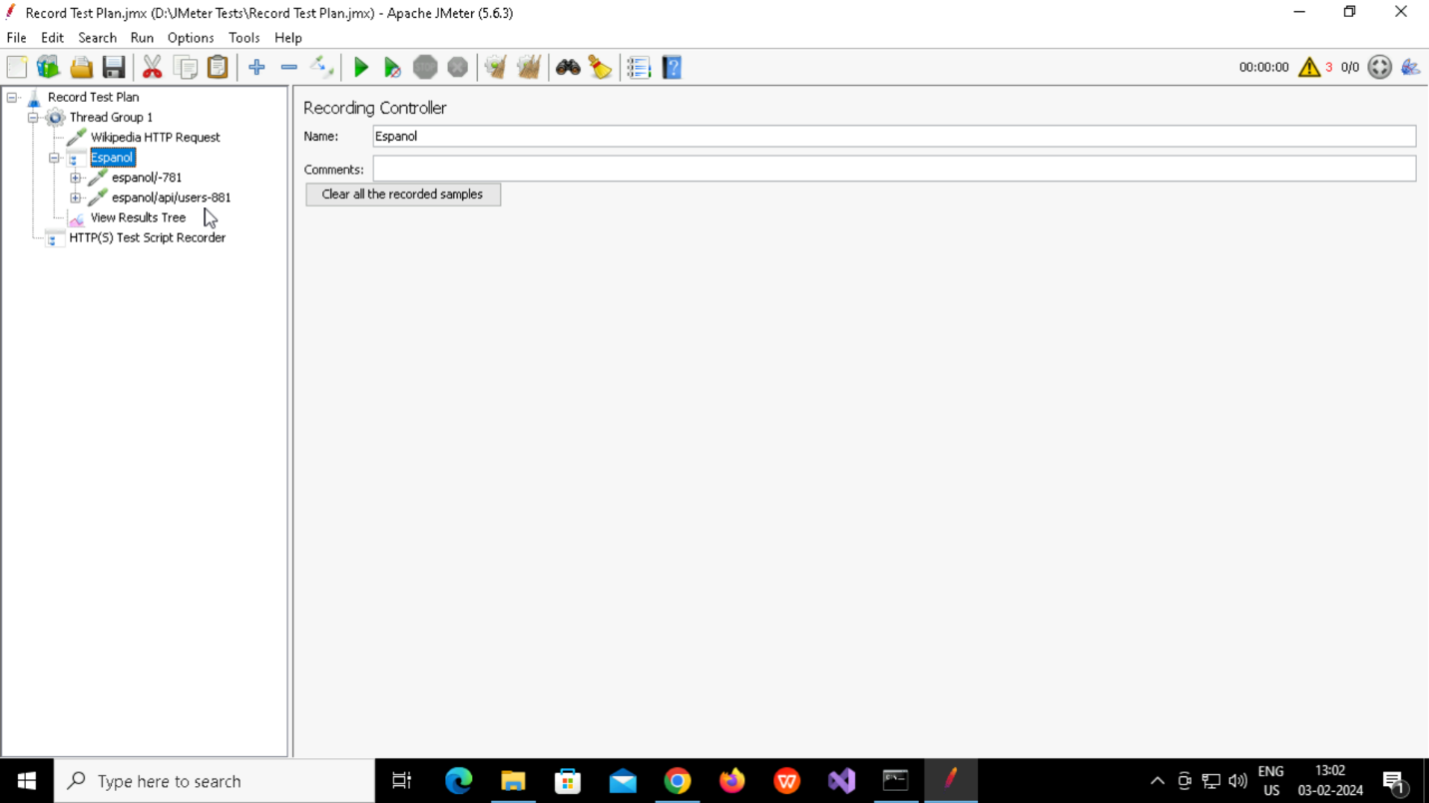

**BlazeMeter**

* Add Extension in chrome & start to record

**Jmeter plugins manager**

* Download [**plugins-manager.jar**](https://jmeter-plugins.org/get/) and put it into lib/ext directory, then restart JMeter.
* Click on options-> Plugins Manager-> Available Plugins -> add plugins like 3 Basic Graphs

**For load testing, use CLI Mode (was NON GUI):**

jmeter -n -t "C:\ApacheJMeter\Big Basket Test Plan.jmx" -l "C:\ApacheJMeter\BigBasket Logfile.csv" -e -o "C:\ApacheJMeter\BigBasketReport"